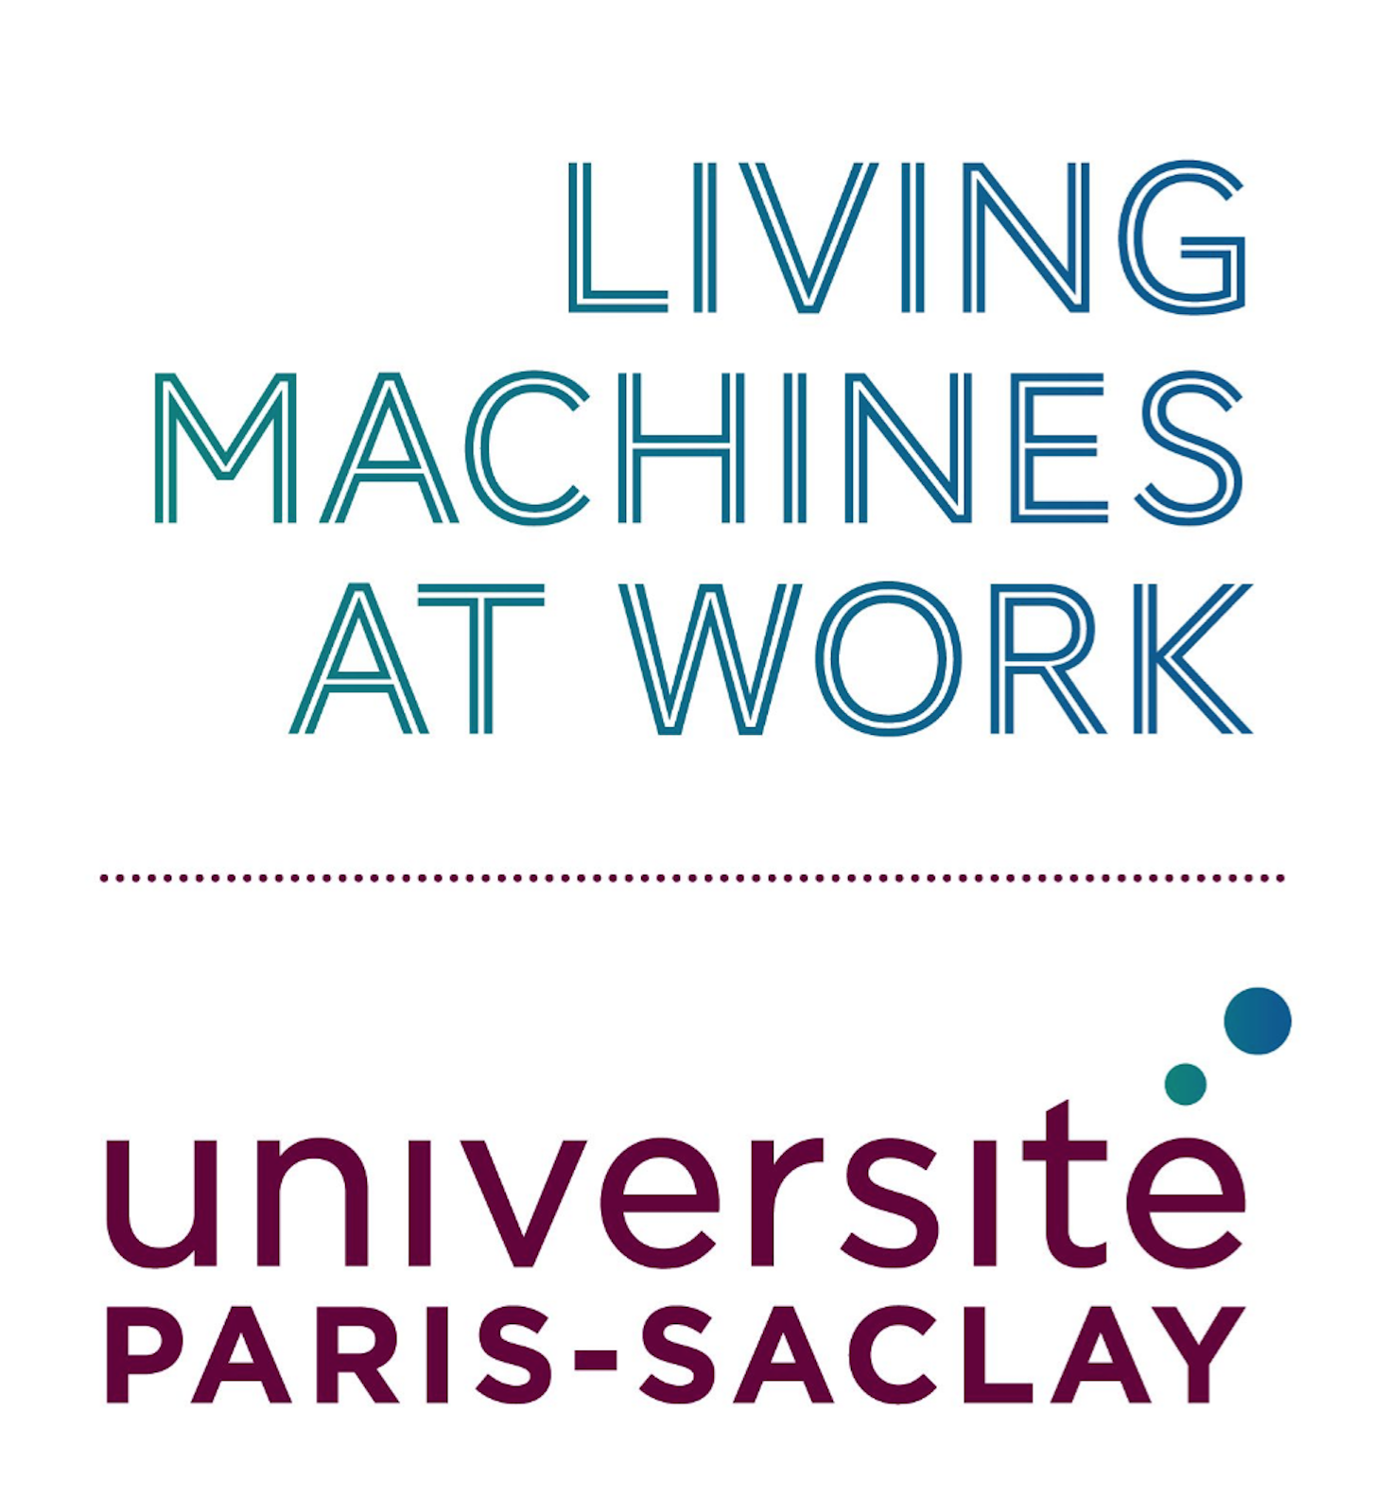

Application form
Meeting

Read the guidelines: https://www.universite-paris-saclay.fr/livingmachines
Submit your application as a single PDF file to living-machines.lptms@universite-paris-saclay.fr

Type of scientific event (scientific meeting, technological workshop, summer school, other):

Title

Expected number of participants

Place (if known):

Dates (approximate dates if not known):
Note that it is possible to change these dates but the meeting must be organised within 6 months of this date.

Applicant
Name, First Name, function :
Laboratory (unit) :
Team :
Graduate School :
e-mail :

For all other members of the organisation
Name, First Name, function :
Laboratory (unit) :
Team :
Graduate School :
e-mail :

Proposal (300 words)
Context, aim and interdisciplinary aspects

Provisional program
Include information such as the title of the sessions, the names of confirmed speakers, the organization of round tables, social events…

Requested budget
Total financial contribution, detailed budget, justification of the budget…

To which research axis(es) is the project linked?

¨ structure and dynamics of living machines
¨ role of living machines in intracellular organization
¨ role of living machines in cellular heterogeneity within populations
¨ computational models of living machines
¨ bioinspired and synthetic living machines

